Chapter 4: SYSTEM DESIGN

4.1 System Architecture and Program Flow
The Dubjly system employs a modular, pipeline-based architecture that transforms video content through a series of specialized processing stages. The system is designed with clear separation of concerns, enabling independent development, testing, and maintenance of each component while ensuring seamless data flow and integration.

System Architecture Overview
The overall system architecture follows a sequential processing model with five major processing stages, supported by a robust API layer and modular component design. The architecture emphasizes scalability, maintainability, and performance optimization.
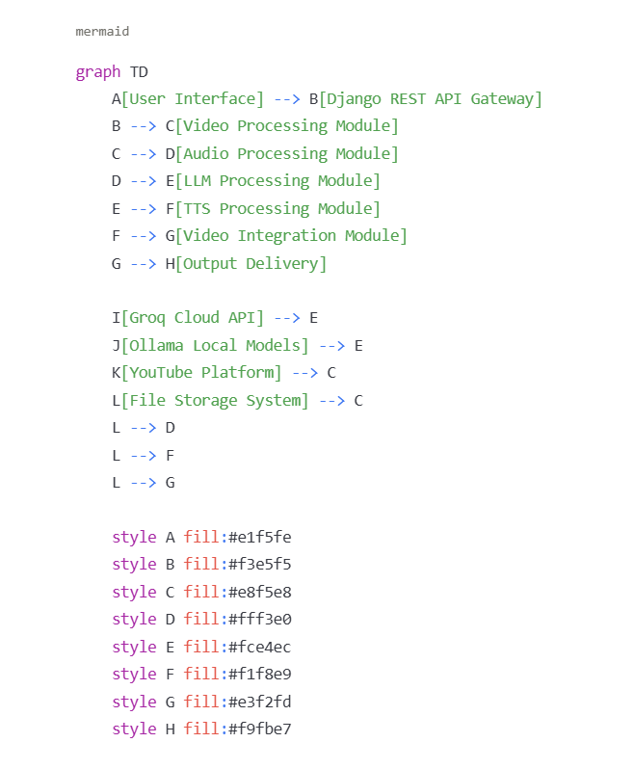
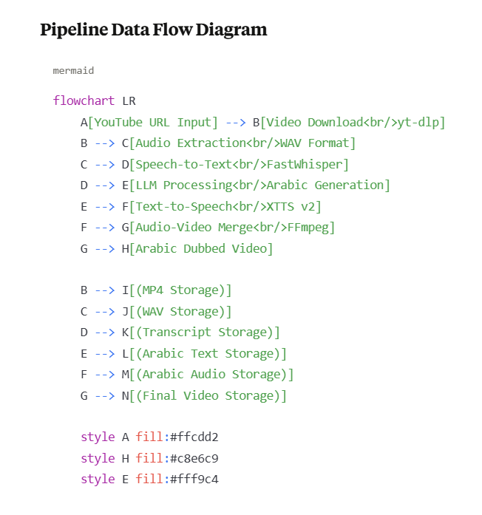

4.1.1 Major Modules

4.1.1.1 Video Acquisition Module
Purpose: Handles video downloading, validation, and initial processing from YouTube and other supported platforms.
Core Responsibilities:
- URL validation and metadata extraction
- High-quality video downloading in MP4 format
- Initial audio stream separation
- File organization and storage management
Key Technologies:
- yt-dlp for video downloading
- FFmpeg for format handling
- Django models for metadata storage
Module Architecture:
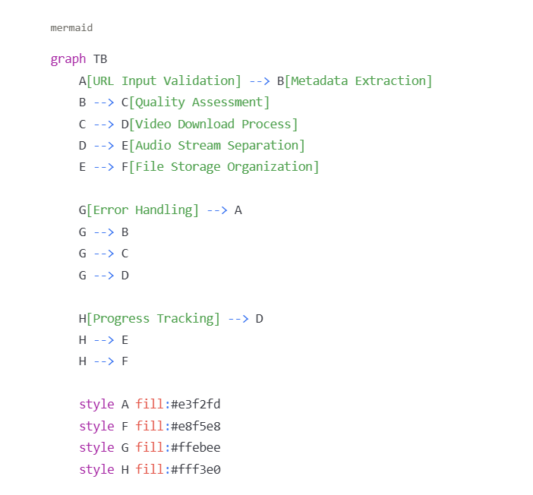

4.1.1.2 Audio Processing Module
Purpose: Converts extracted audio into accurate, timestamped text transcripts for further processing.
Core Responsibilities:
- Audio preprocessing and quality enhancement
- Speech-to-text conversion with timestamp accuracy
- Pause-aware segmentation
- Output formatting for LLM processing
Key Technologies:
- FastWhisper for optimized speech recognition
- Audio preprocessing libraries (librosa, soundfile)
- Custom timestamp processing algorithms
Processing Flow:
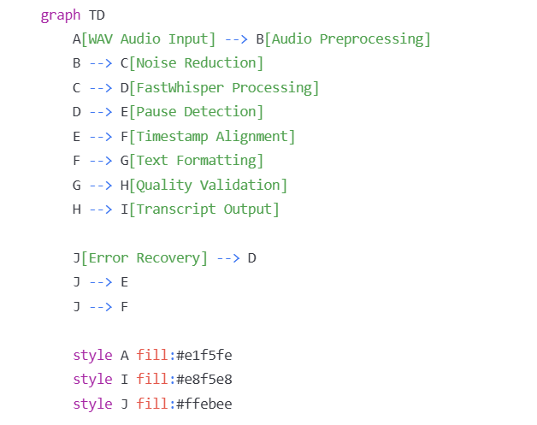

4.1.1.3 Large Language Model (LLM) Processing Module
Purpose: Transforms English transcripts into comprehensive Arabic content including summaries, translations, questions, and interactive responses.
Core Responsibilities:
- Multi-task Arabic content generation
- Model selection and optimization
- Prompt engineering and template management
- Quality assurance and validation
Key Technologies:
- Groq Cloud API for high-performance inference
- Ollama for local model deployment
- Custom OOP architecture with inheritance
- Multiple LLM models (Qwen, Llama variants)
Class Architecture Diagram:
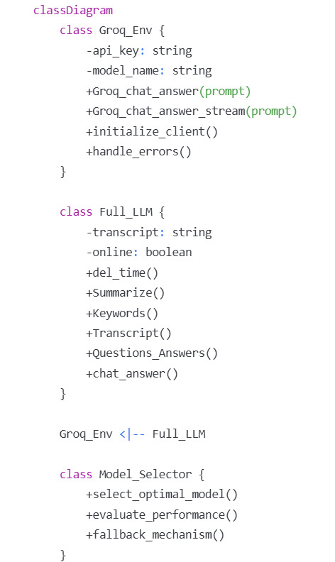

4.1.1.4 Text-to-Speech (TTS) Module
Purpose: Converts Arabic text content into natural, human-like speech audio for video dubbing.
Core Responsibilities:
- High-quality Arabic speech synthesis
- Voice cloning and speaker consistency
- Audio post-processing and optimization
- Multi-format audio output
Key Technologies:
- Coqui TTS with XTTS v2 model
- PyTorch backend for model execution
- Audio processing and enhancement tools
- Custom silence removal algorithms
TTS Processing Pipeline:
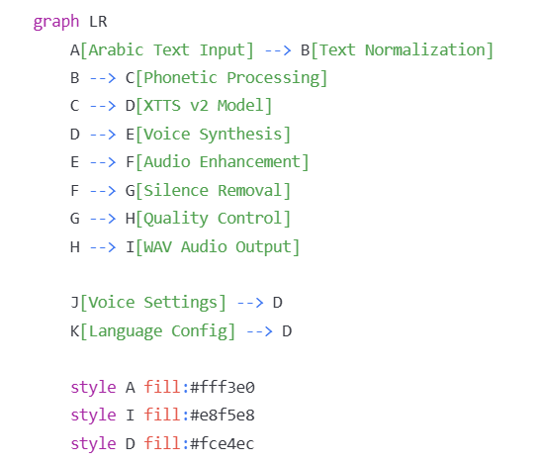

4.1.1.5 Video Integration Module
Purpose: Merges generated Arabic audio with original video content to produce the final dubbed output.
Core Responsibilities:
- Audio-video synchronization
- Format compatibility management
- Quality optimization
- Final output generation
Key Technologies:
- FFmpeg for multimedia processing
- Custom synchronization algorithms
- Multi-format output support
- Quality validation systems
Integration Process:
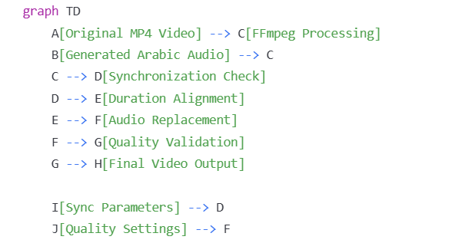

4.1.2 Submodules

4.1.2.1 Video Acquisition Submodules

URL Validation Submodule
Functionality:
- YouTube URL format validation
- Platform compatibility checking
- Malicious URL detection
- Redirect handling
Implementation Details:
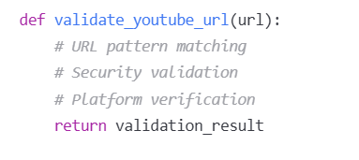

Metadata Extraction Submodule
Functionality:
- Video title and description retrieval
- Duration and quality analysis
- Thumbnail extraction
- Channel information gathering

Download Manager Submodule
Functionality:
- Quality selection optimization
- Progress tracking and reporting
- Bandwidth management
- Retry mechanisms for failed downloads
Process Flow:
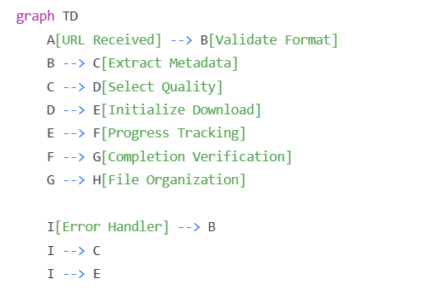

4.1.2.2 Audio Processing Submodules

Audio Preprocessing Submodule
Functionality:
- Format conversion and standardization
- Sample rate optimization
- Noise reduction and filtering
- Volume normalization

FastWhisper Integration Submodule
Functionality:
- Model initialization and configuration
- Batch processing optimization
- Custom parameter tuning
- Output format standardization

Timestamp Processing Submodule
Functionality:
- Word-level timestamp generation
- Pause detection and marking
- Segment boundary identification
- Synchronization data preparation

4.1.2.3 LLM Processing Submodules

Model Management Submodule
Functionality:
- Dynamic model selection
- Performance monitoring
- Resource optimization
- Fallback mechanisms
Model Selection Algorithm:

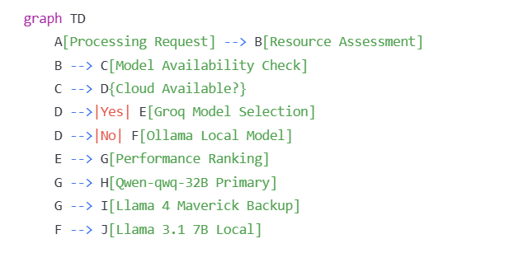

Prompt Engineering Submodule
Functionality:
- Arabic-specific prompt templates
- Context-aware prompt generation
- Task-specific optimization
- Dynamic prompt adaptation

Content Generation Submodule
Functionality:
- Multi-task processing coordination
- Quality validation
- Output formatting
- Error handling and recovery

4.1.2.4 TTS Processing Submodules

Text Normalization Submodule
Functionality:
- Arabic text preprocessing
- Diacritic handling
- Number and symbol conversion
- Pronunciation optimization

XTTS Model Interface Submodule
Functionality:
- Model initialization and configuration
- Voice parameter management
- Batch processing coordination
- Memory optimization

Audio Post-Processing Submodule
Functionality:
- Silence detection and removal
- Audio enhancement and normalization
- Format conversion
- Quality validation
Audio Processing Pipeline:
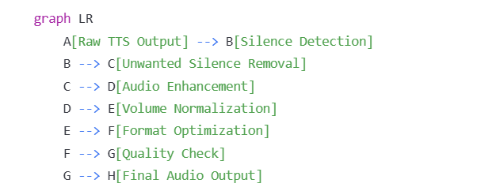

4.1.2.5 Integration and API Submodules

API Gateway Submodule
Functionality:
- Request routing and validation
- Authentication and authorization
- Rate limiting and throttling
- Response formatting

File Management Submodule
Functionality:
- Temporary file handling
- Storage optimization
- Cleanup automation
- Access control

Progress Tracking Submodule
Functionality:
- Real-time status updates
- Processing milestone tracking
- Error reporting
- User notification
System Integration Overview:
